Adding Dynamic Media Files
First install required package:
pip install Pillow
Pillow is required for ImageField.
Change the settings for media settings go to studentList/settings.py
# Media settings - where uploaded files are stored
MEDIA_URL = '/media/'
MEDIA_ROOT = BASE_DIR / 'media'

MEDIA_URL is the URL prefix used in templates: {{ student.student_image.url }} → /media/pics/xxx.jpg.
MEDIA_ROOT will be <project_root>/media/
Make following changes in studentList/urls.py
from django.conf import settings
from django.conf.urls.static import static

# Only in development: serve media files through Django
if settings.DEBUG:
urlpatterns += static(settings.MEDIA_URL, document_root=settings.MEDIA_ROOT)

Your studentList/urls.py will be like:
from django.contrib import admin
from django.urls import path
from . import views

from django.conf import settings
from django.conf.urls.static import static

urlpatterns = [
path('admin/', admin.site.urls),
path('student-list/',views.student_list, name='student_list'),
path('add-student/', views.add_student, name='add_student'),
path('', views.dashboard, name='dashboard'), # Map the root URL to the homePage view
]

# Only in development: serve media files through Django
if settings.DEBUG:
urlpatterns += static(settings.MEDIA_URL, document_root=settings.MEDIA_ROOT)

now make following changes in adminPanel/models.py
from django.db import models
from django.core.validators import FileExtensionValidator

# Create your models here.

class User(models.Model):
id = models.AutoField(primary_key=True)
name = models.CharField(max_length=100, null=False)
email = models.EmailField(max_length=100, unique=True)
gender = models.CharField(
max_length=10,
choices=[
('Male', 'Male'),
('Female', 'Female'),
('Other', 'Other'),
],
null=True,
blank=True
)
date_of_birth = models.DateField(null=True, blank=True)
created_at = models.DateTimeField(auto_now_add=True)

def __str__(self):
return self.name

class Student2(models.Model):
name = models.CharField(max_length=200)
roll = models.IntegerField(unique=True)
phone_number = models.CharField(max_length=20, blank=True)
email = models.EmailField(max_length=254, blank=True)
address = models.TextField(blank=True)
department = models.CharField(max_length=100, blank=True)

# uploaded image saved into MEDIA_ROOT/pics/
student_image = models.ImageField(
upload_to='pics/',
validators=[FileExtensionValidator(['jpg', 'jpeg', 'png'])],
blank=True,
null=True,
help_text='Upload a portrait image (jpg, png, jpeg).'
)

# uploaded pdf saved into MEDIA_ROOT/pdfs/ and restricted to .pdf extension
cv = models.FileField(
upload_to='pdfs/',
validators=[FileExtensionValidator(['pdf'])],
blank=True,
null=True,
help_text='Upload CV in PDF format.'
)

created_at = models.DateTimeField(auto_now_add=True) # optional, useful for "recent" queries

def __str__(self):
return f"{self.name} ({self.roll})"

adminPanel/admin.py — register model
from django.contrib import admin

from adminPanel.models import Student2
admin.site.register(Student2)

Now run following commands
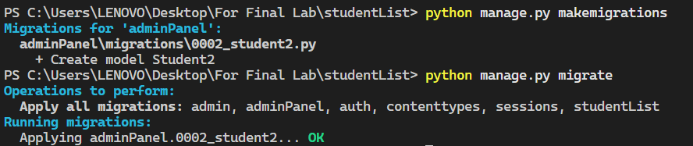

Now run your project and go to admin panel you will get admin Dashboard as like fellow:
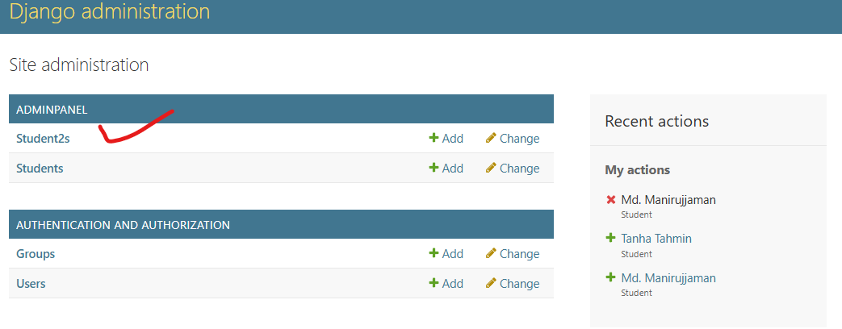
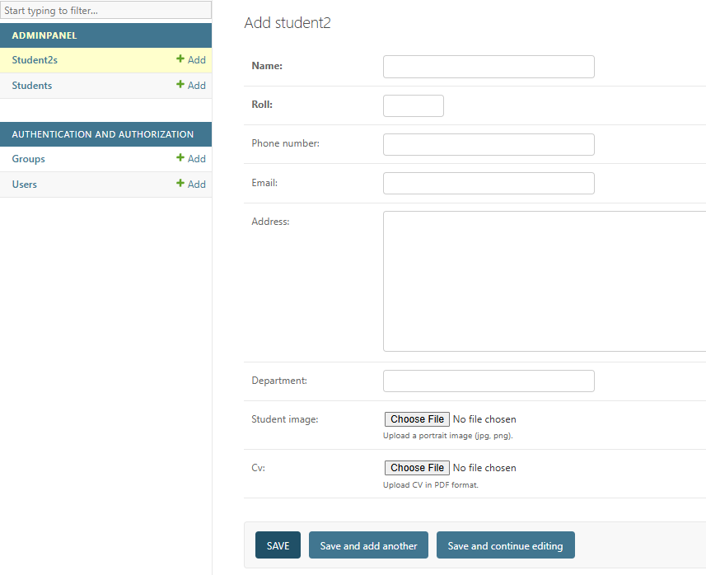

Fill the form with valid information:
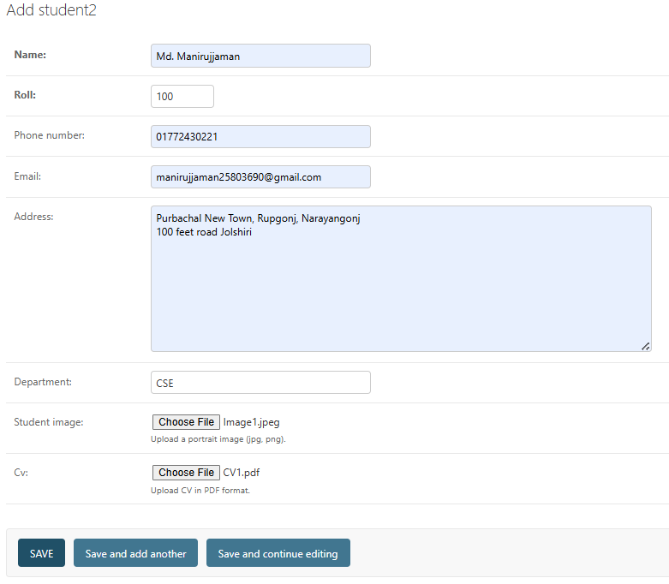
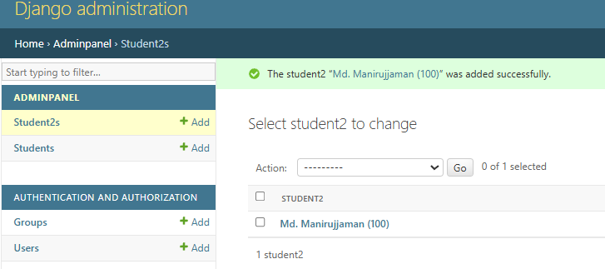
Open DB_Browser you will get your desire output:
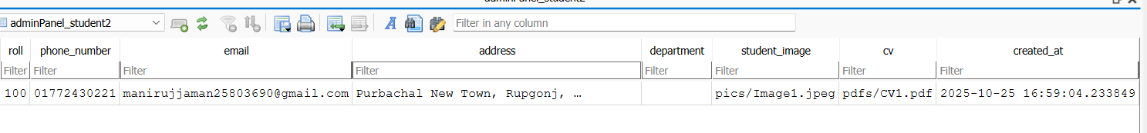
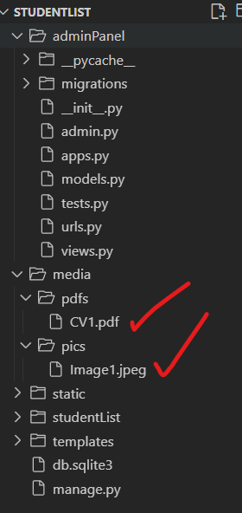
We are using basic registration structure for model registration to admin panel
admin.site.register(Student2)
problem is this process is that we cannot customize how table looks or behaves in the admin, like we cannot choose columns to display, add search, or filters. Thus we can use Custom admin class using @admin.register()
make changes to you adminPanel/admin.py as follow:
from django.contrib import admin

from adminPanel.models import Student2
class Student2Admin(admin.ModelAdmin):
list_display = ('name', 'roll', 'department', 'email', 'created_at')
search_fields = ('name', 'roll', 'department', 'email')
list_filter = ('department', 'created_at')

admin.site.register(Student2,Student2Admin)

you will get your admin panel for this table as given
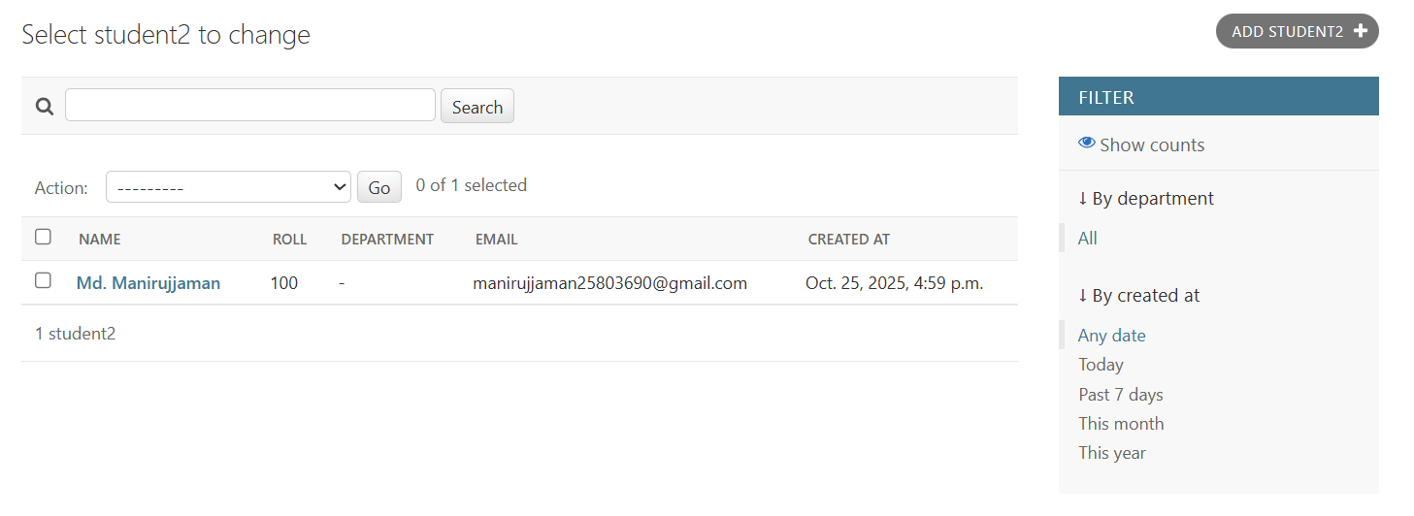
list_display = (...)
- Chooses columns to show in the admin list page.
- Example: Instead of showing only the default __str__(), you see name, roll, department, email, created_at.
search_fields = (...)
- Adds a search box in the admin page.
- Admin can search by name, roll, department, email.
list_filter = (...)
- Adds filter options on the right side of the admin page.
- You can filter students by department or creation date.

Now Let’s create a student_grid.html page to show the student information into grids.
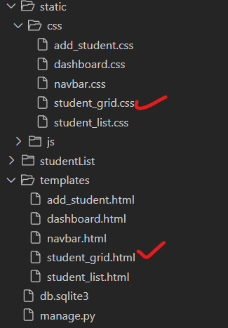
For student_grid.html
<!DOCTYPE html>
<html lang="en">
<head>
<meta charset="UTF-8">
<title>Student Grid</title>
{% load static %}
<link rel="stylesheet" href="{% static 'css/student_grid.css' %}">
</head>
<body>
<h1>🎓 Student Directory</h1>

<div class="grid-container">

<div class="card">
<a href="#">
<img src="https://picsum.photos/200?random=1" alt="Student 1">
</a>
<h3>Rahim Ahmed</h3>
<p>Roll: 101</p>
</div>

<div class="card">
<a href="#">
<img src="https://picsum.photos/200?random=2" alt="Student 2">
</a>
<h3>Karim Hossain</h3>
<p>Roll: 102</p>
</div>

<div class="card">
<a href="#">
<img src="https://picsum.photos/200?random=3" alt="Student 3">
</a>
<h3>Sadia Akter</h3>
<p>Roll: 103</p>
</div>

<div class="card">
<a href="#">
<img src="https://picsum.photos/200?random=4" alt="Student 4">
</a>
<h3>Nusrat Jahan</h3>
<p>Roll: 104</p>
</div>

<div class="card">
<a href="#">
<img src="https://picsum.photos/200?random=5" alt="Student 5">
</a>
<h3>Fahim Islam</h3>
<p>Roll: 105</p>
</div>

<div class="card">
<a href="#">
<img src="https://picsum.photos/200?random=6" alt="Student 6">
</a>
<h3>Arifur Rahman</h3>
<p>Roll: 106</p>
</div>

<div class="card">
<a href="#">
<img src="https://picsum.photos/200?random=7" alt="Student 7">
</a>
<h3>Jannatul Ferdous</h3>
<p>Roll: 107</p>
</div>

<div class="card">
<a href="#">
<img src="https://picsum.photos/200?random=8" alt="Student 8">
</a>
<h3>Tanvir Hasan</h3>
<p>Roll: 108</p>
</div>

<div class="card">
<a href="#">
<img src="https://picsum.photos/200?random=9" alt="Student 9">
</a>
<h3>Mahmudul Hasan</h3>
<p>Roll: 109</p>
</div>

<div class="card">
<a href="#">
<img src="https://picsum.photos/200?random=10" alt="Student 10">
</a>
<h3>Rifat Chowdhury</h3>
<p>Roll: 110</p>
</div>

</div>

<div class="pagination">
<a href="#">⬅ Previous</a>
<span>Page 1 of 1</span>
<a href="#">Next ➡</a>
</div>
</body>
</html>

student_grid.css
body {
font-family: 'Segoe UI', sans-serif;
background-color: #f7f9fc;
text-align: center;
padding: 20px;
}

h1 {
color: #1a237e;
margin-bottom: 30px;
}

.grid-container {
display: grid;
grid-template-columns: repeat(auto-fill, minmax(200px, 1fr));
gap: 25px;
justify-content: center;
margin: 0 auto;
max-width: 1100px;
}

.card {
background: #fff;
border-radius: 12px;
box-shadow: 0 4px 8px rgba(0,0,0,0.1);
overflow: hidden;
transition: transform 0.2s ease, box-shadow 0.2s ease;
}

.card:hover {
transform: translateY(-5px);
box-shadow: 0 8px 16px rgba(0,0,0,0.2);
}

.card img {
width: 100%;
height: 180px;
object-fit: cover;
}

.card h3 {
margin: 10px 0 5px;
color: #0d47a1;
}

.card p {
margin-bottom: 15px;
color: #424242;
}

.pagination {
margin-top: 25px;
}

.pagination a {
text-decoration: none;
padding: 8px 15px;
background-color: #1a237e;
color: white;
border-radius: 5px;
margin: 0 5px;
}

.pagination span {
font-weight: bold;
margin: 0 10px;
}

Let’s render the HTML page in studentList/views.py
from django.shortcuts import render

def student_grid(request):
return render(request, 'student_grid.html')

Now set the URL for this page to adminPanel/urls.py
from django.contrib import admin
from django.urls import path
from adminPanel import views

urlpatterns = [
path('student-grid/', views.student_grid, name='student_grid'),
]

Make some changes in studentList/urls.py
from django.contrib import admin
from django.urls import path,include
from studentList import views

from django.conf import settings
from django.conf.urls.static import static

urlpatterns = [
path('admin/', admin.site.urls),
path('student-list/',views.student_list, name='student_list'),
path('add-student/', views.add_student, name='add_student'),
path('', views.dashboard, name='dashboard'), # Map the root URL to the homePage view
path('', include('adminPanel.urls')),
]

# Only in development: serve media files through Django
if settings.DEBUG:
urlpatterns += static(settings.MEDIA_URL, document_root=settings.MEDIA_ROOT)

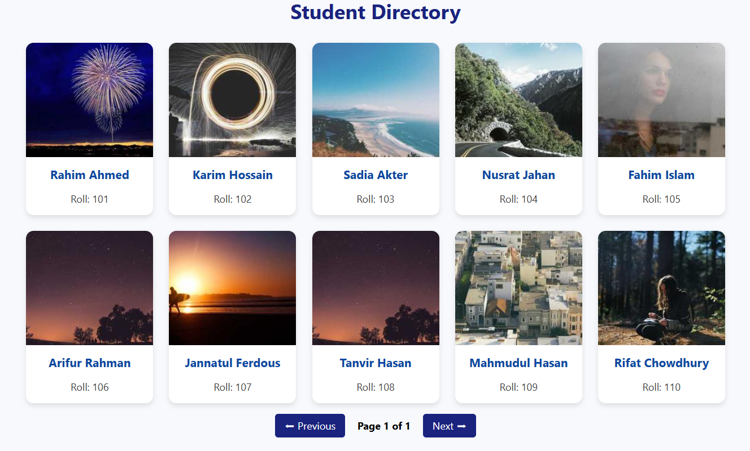

Now remove all dummy data of student_grid.html keep only one grid we will implement that by fetching data from database.
Now make the following changes into the adminPanel/views.py in the student_grid() function.
from .models import Student2
from django.core.paginator import Paginator

def student_grid(request):
students = Student2.objects.all().order_by('roll')
paginator = Paginator(students, 2)
page_number = request.GET.get('page')
page_obj = paginator.get_page(page_number)
context = {
'page_obj': page_obj,
}
return render(request, 'student_grid.html',context)

Let’s say i have inserted 4 records in my database student2 table
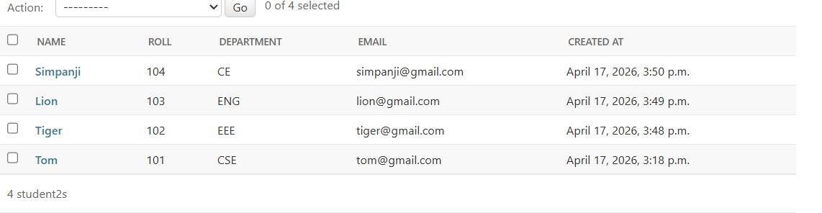
Now make the following changes to your student_grid.html
<!DOCTYPE html>
<html lang="en">
<head>
<meta charset="UTF-8" />
<title>Student Grid</title>
{% load static %}
<link rel="stylesheet" href="{% static 'css/student_grid.css' %}" />
</head>
<body>
<h1>Student Directory</h1>

<div class="grid-container">
{% for student in page_obj %}
<div class="card">
<a href="#">
<img src="{{student.student_image.url}}" alt="{{student.name}}" />
</a>
<h3>{{student.name}}</h3>
<p>Roll : {{student.roll}}</p>
</div>
{% endfor %}
</div>

<div class="pagination">
{% if page_obj.has_previous %}
<a href="?page={{ page_obj.previous_page_number }}">⬅ Previous</a>
{% endif %}
<span>Page {{ page_obj.number }} of {{ page_obj.paginator.num_pages }}</span>
{% if page_obj.has_next %}
<a href="?page={{ page_obj.next_page_number }}">Next ➡</a>
{% endif %}
</div>
</body>
</html>

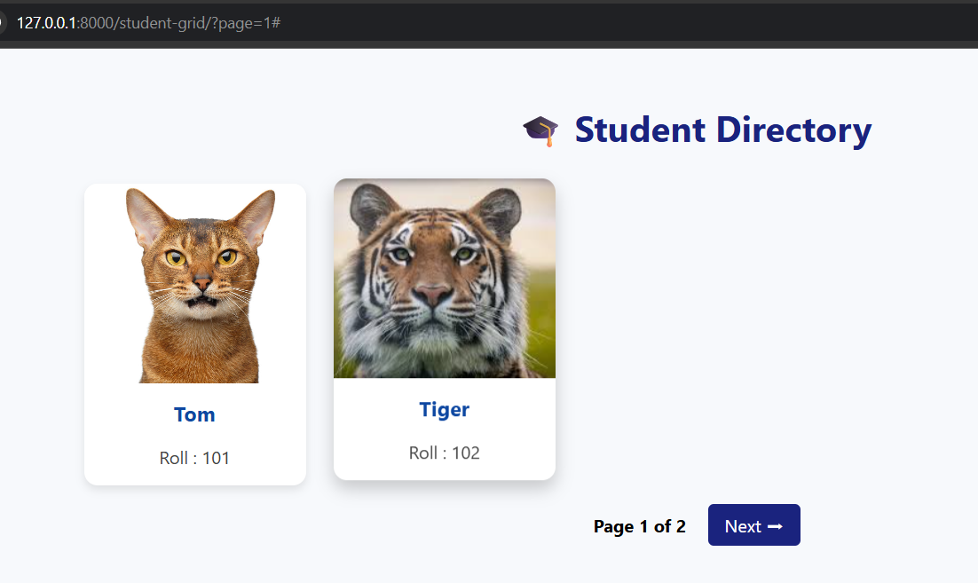
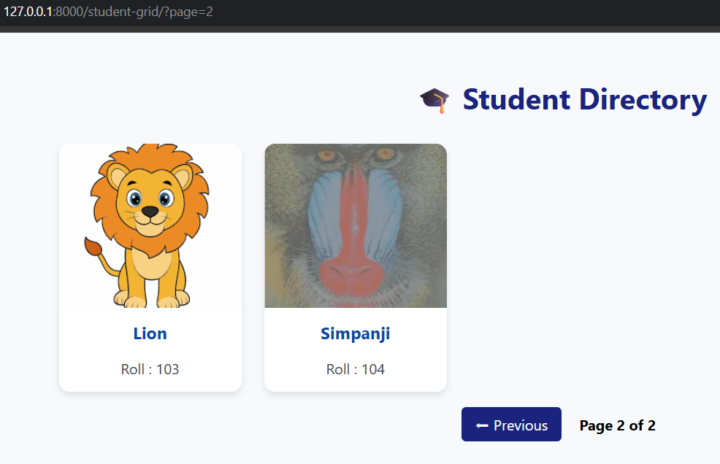
Now create a student_detail.html page that will show detail information after clicking grid for that make the following changes into the views.py
from django.shortcuts import get_object_or_404
def student_detail(request, pk):
student = get_object_or_404(Student2, pk=pk)
return render(request, 'student_detail.html', {'student': student})

now set the url for student_detail.html page.
path('student-detail/<int:pk>/', views.student_detail, name='student_detail'),

and set the grid or card link in student_grid.html
<a href="{% url 'student_detail' student.pk %}">

student_detail.html
{%load static%}
<!DOCTYPE html>
<html lang="en">
<head>
<meta charset="UTF-8">
<title>{{ student.name }}</title>
<link rel="stylesheet" href="{% static 'css/student_grid.css' %}">
</head>
<body>
<h2>{{ student.name }} (Roll: {{ student.roll }})</h2>
<img src="{{ student.student_image.url }}" width="200"><br>
<p><strong>Email:</strong> {{ student.email }}</p>
<p><strong>Phone:</strong> {{ student.phone_number }}</p>
<p><strong>Department:</strong> {{ student.department }}</p>
<p><strong>Address:</strong> {{ student.address }}</p>
<a href="{{ student.cv.url }}" target="_blank">📄 Open CV</a><br>
<a href="{% url 'student_grid' %}">⬅ Back to List</a>
</body>
</html>
Let’s click on Roll: 100 image you will see the detail page for that grid.
